Name :-Hanifan Nurul Haq 6706184096
-M. Faishal Hasbi 6706184091
Class :D3IF-42-02

Memory Management
1. free -m
the free command is used to show total amount of free and used physical memory, total amount of swap memory In the system and display buffers and caches used by kernel. And -m command is used to display size in megabyte. here’s the example of this command
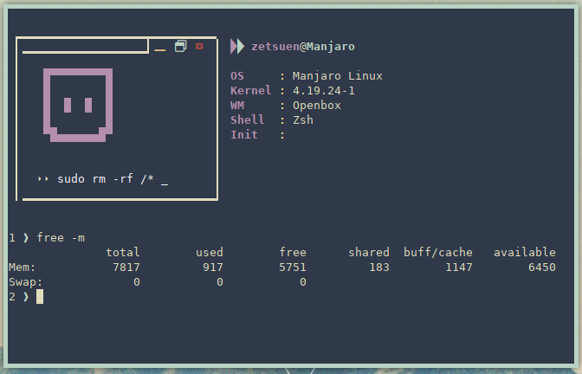

2. /proc/meminfo/
we can check memory usage by reading meminfo file with cat /proc/meminfo/.
here’s example of this command
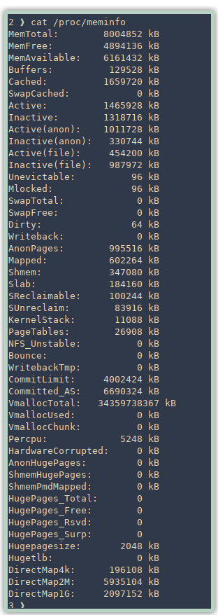

3. vmstat -s
vmstat command with -s option is used to display the memory usage statistic much like the above command. here’s the example for this command
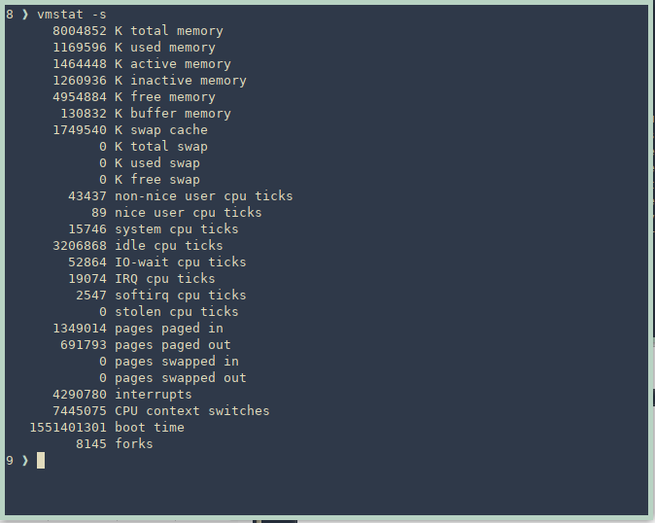

4. Top
Top command is task manager alike application to show not only memory usage but also display cpu usage and program that running in the background. here’s the example

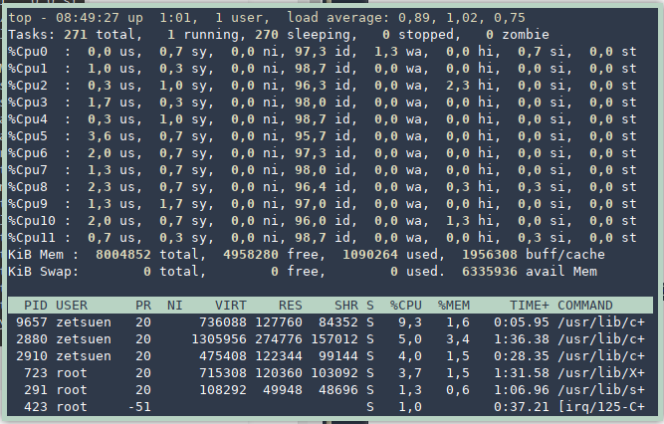
5. htop
htop command is almost the same as top command but htop is more comperhensive compared to top. here’s the example of this command
